
IR PREVIEW
Preliminary highlights from Volume 4, Number 2 Volume
current IR studies May 2001
Office of Institutional Research http://irweb.erau.edu Daytona Beach, FL 32114-3900 (386) 226-6225

IN THIS ISSUE
- Fall 2000 Student Satisfaction Survey (Daytona Beach and Prescott students)

FALL 2000 STUDENT SATISFACTION SURVEY

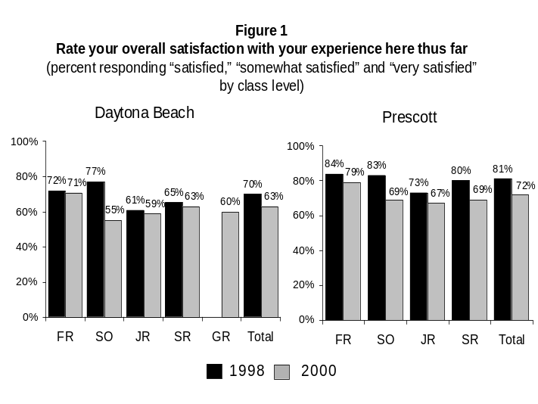 The Office of Institutional Research (IR) administered the Student Satisfaction Inventory™ (SSI) to a sample of students from all class levels and majors at both the Daytona Beach and Prescott campuses during October 2000. The SSI, an instrument developed by the Noel-Levitz consulting firm, presents students with items that cover a full range of college experiences, and asks them to rate both the level of importance as well as the level of satisfaction they assign to each area.
The process of survey distribution was as follows: IR identified types and number of courses needed in order to obtain a representative sample of students by class level and major. Faculty members were asked to participate by volunteering class time, thus allowing the completion of the survey in class. A total of 1,136 surveys were completed at both campuses. This represents approximately 18% of the total student population. Data were statistically weighted where necessary to correct for disproportionate response rates, so that results are representative of all Fall 2000 ERAU students. IR would like to thank all faculty and staff who facilitated the completion of this study.
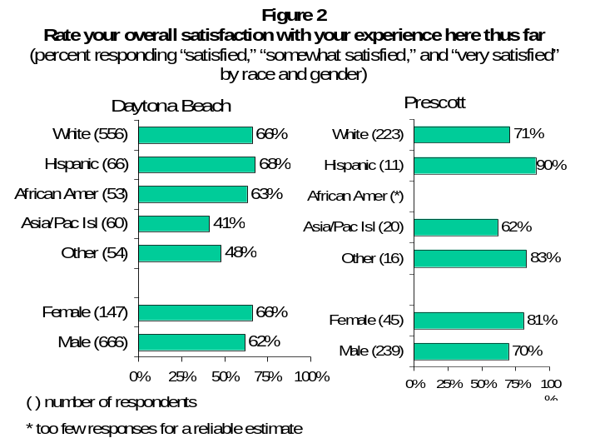This issue of the IR Preview summarizes survey findings and where appropriate, it compares results to 1998 data. In addition, ERAU responses are compared to those of recent SSI participants at other private, four-year institutions. National results are based on 319,346 student records from 411 four-year private institutions. Fifty percent of these four-year schools include colleges where the baccalaureate is the highest degree awarded, and 25% represent schools where the master's degree is the highest degree awarded. About 70% of the institutions have an enrollment of 2,000 or less.
Survey results from this national comparative group are only available in the form of an “average response” - a legend for each corresponding seven-point Likert response scale is provided. While this method allows for quick identification of differences between ERAU students and those in the national cohort, some may find the interpretation of an “average response” to be cumbersome. For this reason, ERAU results are also presented in “percentage response” form, where the seven-point response scale is collapsed into three categories, and the proportion of responses in one or all the categories are displayed.

- Overall Satisfaction

Students at the Prescott campus were more likely than students at the Daytona Beach campus to indicate satisfaction with their ERAU experience (72% vs. 63%). This is true for all class levels. However, at both campuses and across all class levels, overall satisfaction ratings declined from those of the 1998 survey administration (Figure1).
Regardless of campus, Asian/Pacific Islander students are less satisfied than other ethnic groups. Females are more likely than males to indicate satisfaction with their ERAU experience (Figure 2).
As seen in Figure 3, in general, the average response indicates that ERAU students and students at other four-year colleges feel “somewhat satisfied.” However, while satisfaction scores of students at four-year, private institutions did not change from 1998 to 2000, scores of ERAU students declined.

- 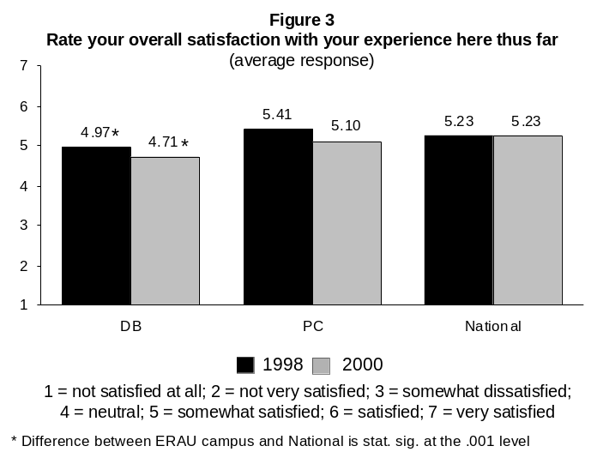Overall Satisfaction by Major

At Daytona Beach, majors with at least 75% of students indicating overall satisfaction with their ERAU experience include Communications (88%), Civil Engineering (83%), Engineering Physics (83%), Aviation Business Administration (81%), and Aviation Maintenace Management (76%). Aerospace Studies students were less likely than other majors to indicate satisfaction with their overall experience at ERAU (34%) (see Figure 4).
As seen in Figure 5, at the Prescott campus, majors with at least 75% of students showing overall satisfaction include Aerospace Engineering (86%); Science, Technology and Globalization (77%); and Electrical Engineering (75%).

- 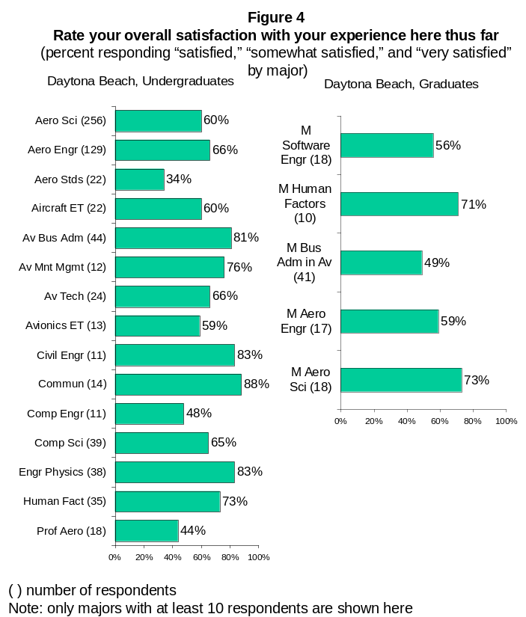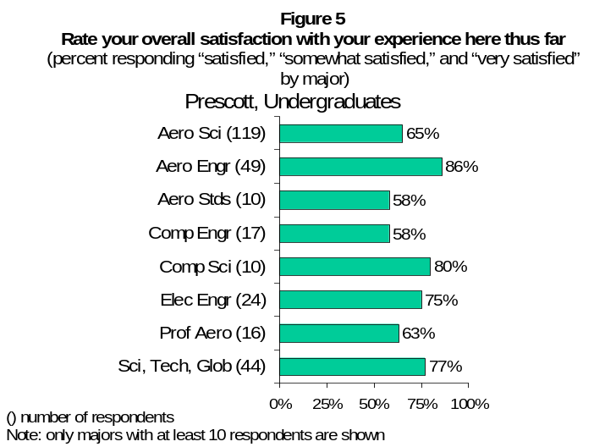Meeting Students’ Expectations

As a whole, the majority of ERAU students at both campuses indicated that their college experience has met or exceeded their expectations (73% for Daytona Beach, 82% for Prescott). However, the rate is lower this year across almost all class levels. As seen in Figure 6, the most marked drop is found among sophomores at Prescott.
As depicted in Figure 7, students of Asian/Pacific Islander origin at Daytona Beach, and Hispanic students at Prescott, are less likely than any other group to perceive that their college experience has met or exceeded their expectations (62% and 68%, respectively). At Daytona Beach, the percentage of females agreeing that their college experience has met or exceeded their expectations was similar to the males (71% vs. 73%). This is also true for Prescott (85% vs. 81%).
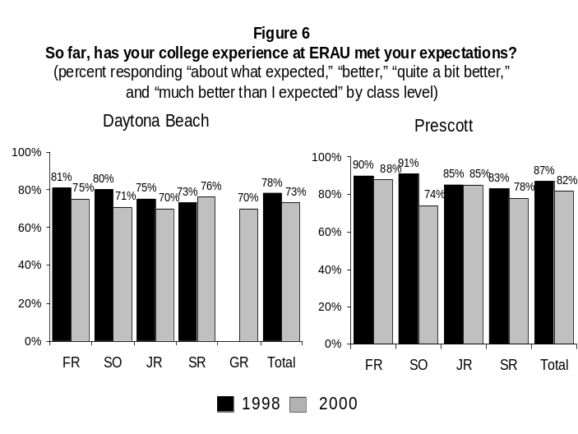For the past two survey administrations, the percentage of students at other four-year, private institutions indicating that their college experience has met or exceeded their expectations has remained unchanged, while ERAU students’ scores have declined slightly (Figure 8).
- 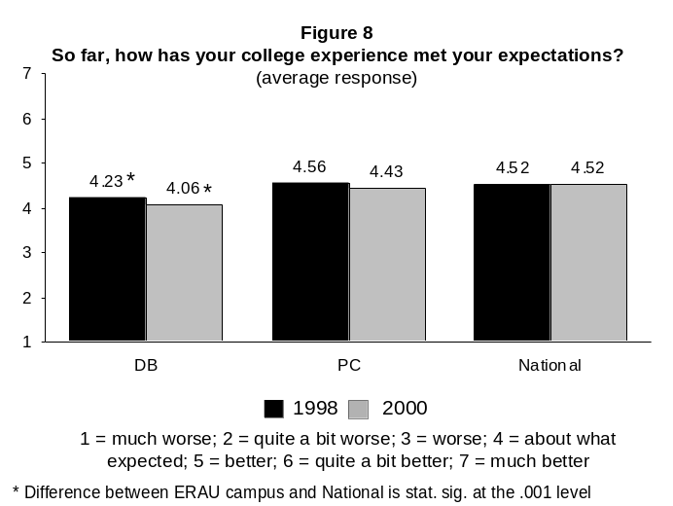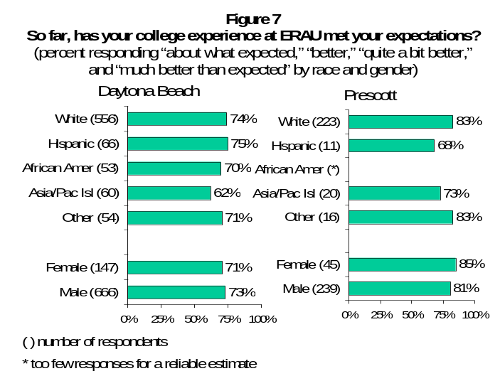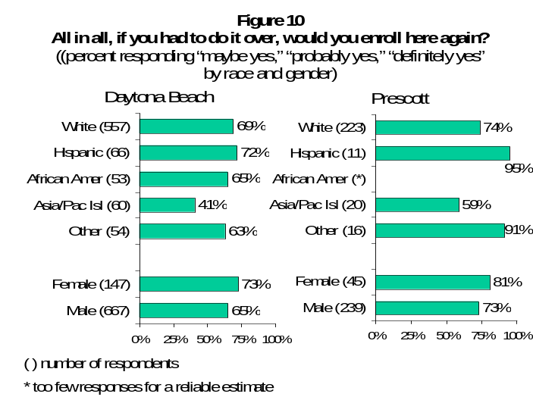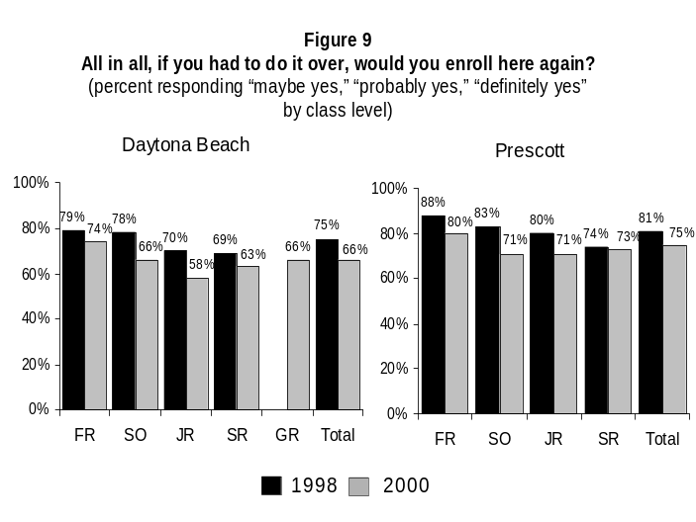Enrolling at ERAU again
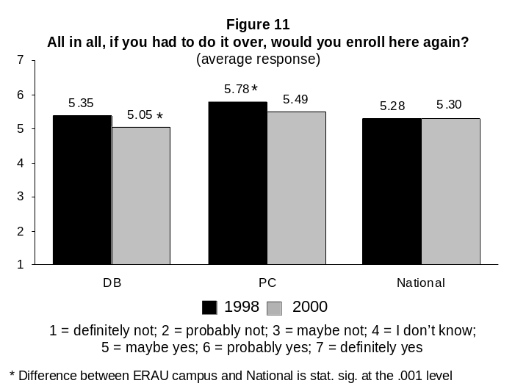
The majority of ERAU students would enroll again if they had to do it all over (66% for Daytona Beach, 75% for Prescott). 1998 and 2000 data show that freshmen at both campuses were the largest group indicating they would enroll again. 2000 survey findings also show that relative to 1998 findings, the percentage of students indicating that they would enroll at ERAU again declined at both campuses and across all class levels (Figure 9).
As presented in Figure 10, Asian/Pacific Islander students at both campuses were less likely than any other group to indicate that they would enroll again (41% for Daytona Beach, 59% for Prescott). Females at both campuses were more likely than males to indicate that they would enroll again.
In Figure 11, average responses show that ERAU students, as well as students from the national comparative group are likely to re-enroll. As indicated by the higher average scores, in both years Prescott students felt stronger than the national comparative group about re-enrolling.

- Importance and Satisfaction Scale Categories

In order to summarize the results of the remaining questionnaire, survey questions were collapsed into 11 similar themes (scales) based on the topic of the question. This classification allows for a more global view of the institution’s environment. Figure 12 presents scale category comparisons for importance ratings and satisfaction ratings, and includes results for the national group.
Importance scores of students at ERAU and other four-year, private institutions are very similar: on average, all items are viewed as “important,” with ‘Instructional Effectiveness’ rated the most important, followed by ‘Academic Advising’ and ‘Safety and Security’. On the other hand, ‘Campus Life’ rated the least important. These findings are similar to 1998 findings. Satisfaction ratings of Daytona Beach students were statistically significantly lower than those of students at other four-year, private institutions in all scale categories except ‘Campus Support Services’. In Prescott, students were statistically significantly less satisfied with ‘Campus Life’ and ‘Service Excellence’.
- 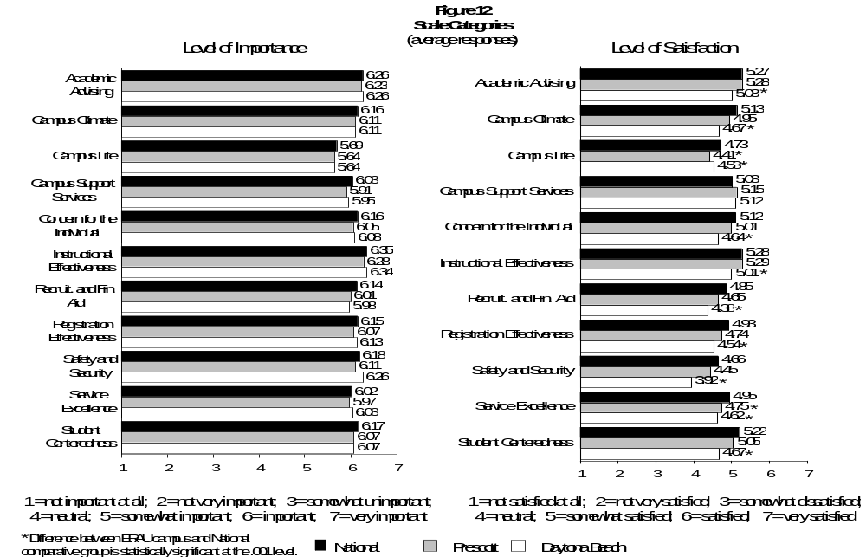Students’ Satisfaction Ratings of Individual Items

Table 1 shows all survey items included under each scale, and average scores comparing ERAU ratings to those of the national group. The statistical significant difference between the ERAU campus average satisfaction score and the national group satisfaction score has been calculated at the .001 level and is represented by an asterisk (*). For the Daytona Beach campus, statistically significant larger means (higher satisfaction than the national group) are found in the following areas: variety of intramural activities, library services, computer labs, bookstore and health services. For the Prescott campus, statistically significant larger means are found in the following areas: computer labs, tutoring services, career services, availability of faculty after classes, well-lighted and secure parking lots, and health services.
In addition to average scores, the last two columns of Table 1 show the percent of ERAU students indicating satisfaction for each survey item. The cells shaded in black represent those areas were at least 75% of students indicated satisfaction. Cells shaded in gray represent areas where less than 50% of ERAU students indicated satisfaction in a particular area. In general, the most satisfaction was found in the following scale categories: advising, campus support services, and instructional effectiveness. The areas of least satisfaction include campus life, concern for the individual, recruitment and financial aid, responsiveness to diverse populations, safety and security, and service excellence.

Table 1: Individual Survey Questions, by Scale - Average and Percentage Scores of Satisfaction Ratings

Survey Question | National Average | DB Average | PC Average | DB % satisfied | PC % satisfied
Academic Advising
My academic advisor is approachable | 5.50 | 5.39 | 5.50 | 76% | 77%
My academic advisor is concerned about my success as an individual | 5.26 | 4.88* | 5.24 | 63% | 71%
My academic advisor helps me set goals to work toward | 4.77 | 4.35* | 4.63 | 50% | 50%
My academic advisor is knowledgeable about requirements in my major | 5.47 | 5.40 | 5.64 | 78% | 83%
Major requirements are clear and reasonable | 5.38 | 5.10* | 5.37 | 72% | 79%
Campus Climate
Most students feel a sense of belonging here | 5.12 | 4.71* | 4.94 | 59% | 68%
The campus staff are caring and helpful | 5.38 | 4.91* | 5.40 | 70% | 82%
Administrators are approachable to students | 4.98 | 4.43* | 4.80 | 52% | 56%
It is an enjoyable experience to be a student on this campus | 5.26 | 4.65* | 4.91* | 59% | 67%
I feel a sense of pride about my campus | 5.08 | 4.75* | 4.73* | 60% | 58%
Students are made to feel welcome on this campus | 5.38 | 5.00* | 5.29 | 69% | 79%
This institution has a good reputation within the community | 5.63 | 5.31* | 4.61* | 72% | 57%
This institution shows concern for students as individuals | 5.19 | 4.30* | 4.99 | 51% | 70%
I generally know what's happening on campus | 4.95 | 4.66* | 4.76 | 59% | 59%
There is a strong commitment to racial harmony on this campus | 5.10 | 4.93* | 5.12 | 58% | 64%
Tuition paid is a worthwhile investment | 4.75 | 4.31* | 4.73 | 51% | 59%
Freedom of expression is protected on campus | 4.93 | 4.89 | 4.90 | 61% | 61%
Channels for expressing student complaints are readily available | 4.55 | 4.04* | 4.10* | 39% | 38%
Campus Life
A variety of intramural activities are offered | 4.77 | 4.96* | 4.54 | 59% | 50%
Living conditions in the residence halls are comfortable (adequate space,  lighting, heat, air conditioning, telephones, etc.). | 4.40 | 4.51 | 4.43 | 53% | 51%
The intercollegiate athletic programs contribute to a strong sense of school spirit | 4.33 | 4.08* | 3.70* | 35% | 26%
Males and females have equal opportunities to participate in intercollegiate athletics | 5.11 | 4.74* | 4.88 | 48% | 54%
There is an adequate selection of food available in the cafeteria | 3.97 | 3.53* | 2.25* | 34% | 13%
Residence hall regulations are reasonable | 4.55 | 4.51 | 4.41 | 52% | 49%
There are a sufficient number of weekend activities for students | 4.26 | 4.11 | 4.05 | 37% | 38%
I can easily get involved in campus organizations | 5.18 | 5.28 | 5.41 | 74% | 76%
The student center is a comfortable place for students to spend their leisure time | 4.82 | 4.38* | 4.04* | 47% | 36%
The student handbook provides helpful information about campus life | 5.14 | 4.69* | 4.98 | 55% | 63%
Student disciplinary procedures are fair | 4.89 | 4.64* | 4.85 | 51% | 56%
New student orientation services help students adjust to college | 5.06 | 4.83* | 4.91 | 59% | 62%
Freedom of expression is protected on campus | 4.93 | 4.89 | 4.90 | 61% | 61%
Student activities fees are put to good use | 4.44 | 4.35 | 4.19 | 48% | 45%
ERAU treatment of students is fair and unbiased regardless of race and gender | N/A |  |  | 68% | 77%
Campus Support Services
Library staff are helpful and approachable | 5.31 | 5.73* | 4.85* | 82% | 56%
Library resources and services are adequate | 4.78 | 5.27* | 4.80 | 76% | 59%
Computer labs are adequate and accessible | 4.82 | 5.39* | 5.65* | 77% | 86%
Tutoring services are readily available | 5.20 | 5.07 | 5.66* | 68% | 76%
Academic support services adequately meet the needs of students | 4.98 | 4.60* | 5.06 | 54% | 66%
There are adequate services to help me decide upon a career | 4.98 | 4.99 | 5.30* | 66% | 76%
Bookstore staff are helpful | 5.16 | 5.39* | 5.13 | 76% | 69%
The Counseling Center offers useful and valuable information and workshops | N/A |  |  | 47% | 53%
International Student Services meet the needs of international students | N/A |  |  | 44% | 44%
The Career Services Office is helpful in assisting me in my search for a job upon completion of studies at ERAU | N/A |  |  | 57% | 67%
Concern for the Individual
Faculty care about me as an individual | 5.32 | 4.71* | 5.31 | 63% | 78%
Counseling staff care about students as individuals | 4.90 | 4.61* | 4.76 | 47% | 49%
Residence hall staff are concerned about me as an individual | 4.88 | 4.45* | 4.51* | 44% | 48%
This institution shows concern for students as individuals | 5.19 | 4.30* | 4.99 | 51% | 70%
Revised table
- Average score: 1 = not satisfied at all; 2 = not very satisfied; 3 = somewhat dissatisfied; 4 = neutral; 5 = somewhat satisfied; 6 = satisfied; 7 = very satisfied.
- (*) Difference between ERAU campus and National group is statistically significant at the .001 level.
- Black shaded cells represent areas where at least 75% of students indicated satisfaction.
- Gray shaded cells represent areas where less than 50% of ERAU students indicated satisfaction.
-Table continues on next page-

Table 1: Individual Survey Questions, by Scale - Average and Percentage Scores of Satisfaction Ratings (Continued)

Survey Question | National Average | DB Average | PC Average | DB % satisfied | PC % satisfied

Instructional Effectiveness
The content of the courses within my major is valuable | 5.49 | 5.29* | 5.59 | 80% | 85%
The instruction in my major field is excellent | 5.43 | 5.22* | 5.64 | 76% | 84%
Faculty are fair and unbiased in their treatment of individual students | 5.09 | 4.82* | 5.15 | 66% | 73%
I am able to experience intellectual growth here | 5.51 | 5.12* | 5.33 | 73% | 78%
There is a commitment to academic excellence on this campus | 5.42 | 5.15* | 5.52 | 74% | 83%
Faculty provide timely feedback about student progress in a course | 5.00 | 4.77* | 5.12 | 62% | 72%
Faculty take into consideration student differences as they teach a course | 4.89 | 4.47* | 4.81 | 55% | 64%
The quality of instruction I receive in most of my classes is excellent | 5.40 | 5.03* | 5.53 | 73% | 81%
There is an adequate selection of courses I want offered at times I can take them | N/A |  |  | 50% | 49%
Class size to faculty ratio is adequate | N/A |  |  | 82% | 84%
ERAU faculty integrate computers into courses (excluding computer science courses) | N/A |  |  | 65% | 71%
The quality of instruction during summer terms is similar to that of the spring and fall terms | N/A |  |  | 66% | 57%
Preparation I am receiving at ERAU for my future occupation is satisfactory | N/A |  |  | 79% | 83%
Adjunct faculty are competent as classroom instructors | 5.08 | 4.75* | 5.14 | 58% | 69%
Faculty are usually available after class and during office hours | 5.52 | 5.36 | 5.77* | 77% | 89%
Nearly all of the faculty are knowledgeable in their field | 5.71 | 5.51* | 5.92 | 82% | 89%
There is a good variety of courses provided on this campus | 5.09 | 4.79* | 4.72* | 64% | 64%
Graduate teaching assistants are competent as classroom instructors | 4.84 | 4.78 | 4.57 | 56% | 44%
Recruitment and Financial Aid
The quality of the ERAU College catalog and admission publications is excellent | N/A |  |  | 68% | 65%
Admissions staff are knowledgeable | 5.13 | 4.64* | 4.94 | 55% | 64%
Admissions counselors respond to prospective students' unique requests | 4.97 | 4.47* | 4.75 | 48% | 53%
Admissions counselors accurately portray the campus when recruiting | 4.81 | 4.14* | 4.45* | 43% | 49%
Financial aid counselors are helpful | 4.82 | 4.37* | 4.78 | 47% | 57%
Financial aid awards are announced to students in time to be helpful in college planning | 4.69 | 4.16* | 4.38* | 45% | 46%
Adequate financial aid is available for most students | 4.67 | 3.88* | 4.23* | 39% | 46%
Registration Effectiveness
Billing policies are reasonable | 4.48 | 4.01* | 4.16* | 43% | 44%
The cashiers office is open during hours which are convenient | 4.97 | 4.50* | 4.65* | 50% | 51%
The personnel involved in registration are helpful | 5.15 | 4.87* | 5.02 | 66% | 69%
I am able to register for classes I need with few conflicts | 4.90 | 4.45* | 4.57* | 57% | 57%
Class change (drop/add) policies are reasonable | 5.15 | 4.86* | 5.32 | 63% | 76%

Responsiveness to Diverse Populations
Institution’s commitment to part-time students | 4.96 | 4.69* | 4.72 | 47% | 48%
Institution’s commitment to evening students | 4.90 | 4.36* | 4.16* | 41% | 32%
Institution’s commitment to older, returning students | 5.10 | 4.75* | 4.87 | 48% | 55%
Institution’s commitment to underrepresented populations | 4.90 | 4.68* | 4.73 | 49% | 49%
Institution’s commitment to commuters | 4.89 | 4.30* | 4.72 | 45% | 52%
Institution’s commitment to students with disabilities | 4.89 | 4.81 | 4.73 | 49% | 48%

Safety and Security
The campus is safe and secure for all students | 5.47 | 4.95* | 5.43 | 67% | 77%
The amount of student parking space on campus is adequate | 3.75 | 2.26* | 2.81* | 13% | 22%
Parking lots are well-lighted and secure | 4.73 | 4.19* | 5.09* | 49% | 67%
Security staff respond quickly in emergencies | 4.64 | 4.27* | 4.50 | 41% | 46%

Service Excellence
I seldom get the 'run-around' when seeking information on this campus | 4.55 | 3.14* | 3.94* | 28% | 44%
I generally know what's happening on campus | 4.95 | 4.66* | 4.76 | 59% | 59%
Channels for expressing student complaints are readily available | 4.55 | 4.04* | 4.10 | 39% | 38%
The staff in the health services area are competent | 4.72 | 5.02* | 5.15* | 62% | 66%
- Average score: 1 = not satisfied at all; 2 = not very satisfied; 3 = somewhat dissatisfied; 4 = neutral; 5 = somewhat satisfied; 6 = satisfied; 7 = very satisfied.
- (*) Difference between ERAU campus and National group is statistically significant at the .001 level.
- Black shaded cells represent areas where at least 75% of students indicated satisfaction.
- Gray shaded cells represent areas where less than 50% of ERAU students indicated satisfaction.
The IR Preview provides the ERAU community with information regarding current studies conducted by the Office of Institutional Research. The IR Preview is published whenever preliminary statistics of developing projects become available. Please refer to the forthcoming full report for final and/or additional statistics.

